Southeastern Vermont Welcome Center
Interstate 91 North, Guilford Vermont

Art Exhibit Information

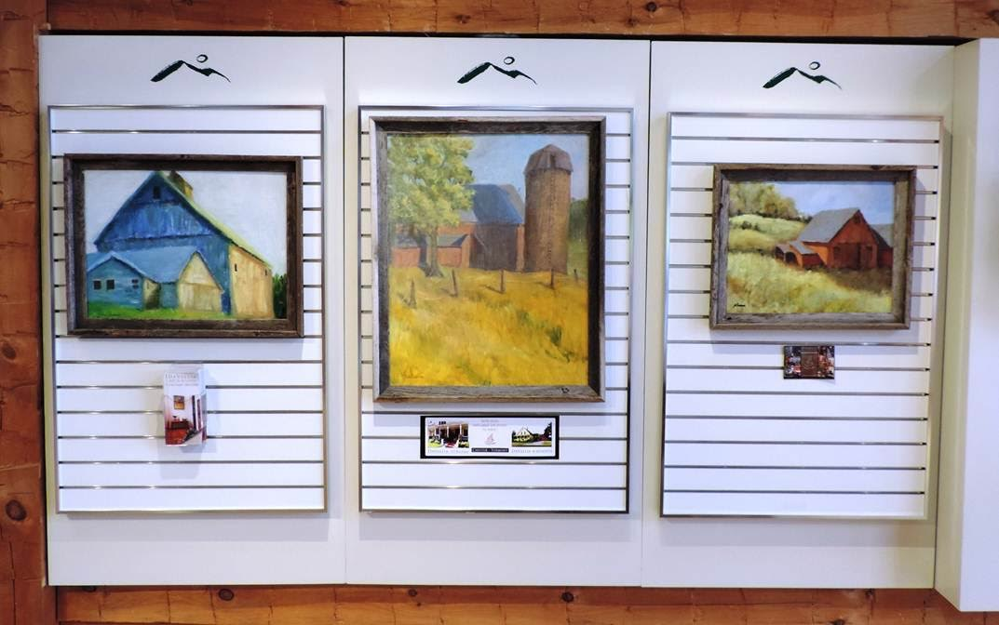
Exhibits are for Vermont artists. Art is on display for one month from 7am to 11pm daily.

Size of artwork must be 14” x 17”, or larger.

Insurance is the responsibility of the artist.

Prices are not permitted on artwork.

Artwork needs to have wire backs.

A sign with the name of your business, the town and your website need to be prominently visible.

Three panels, each 32 inches wide & 48 inches tall.

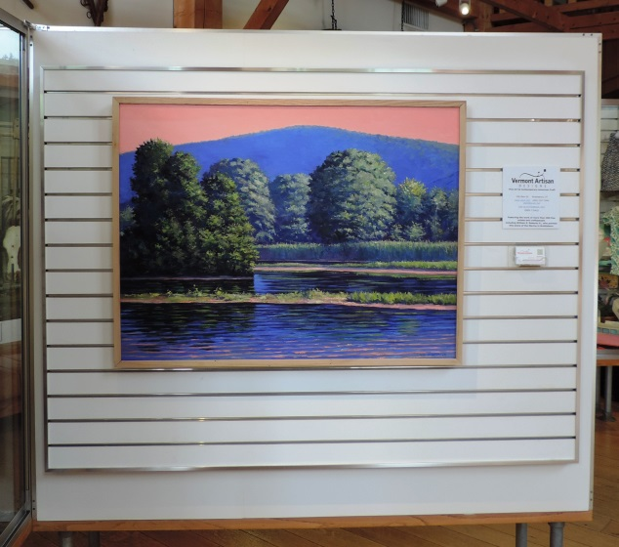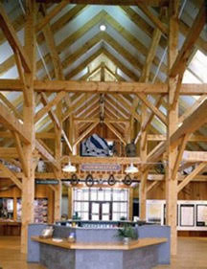
Large panel is 5 feet wide x 37 inches tall. Business/rack cards placed on shelf of front desk.
Holders are provided.

The center is listed as an official stop for the monthly Brattleboro Gallery Walk. A short artist write up/picture of your art work will be listed in the Gallery Walk publication.

Please email bgs.guilfordwelcomecenter@vermont.gov, for further information or to schedule an exhibit.

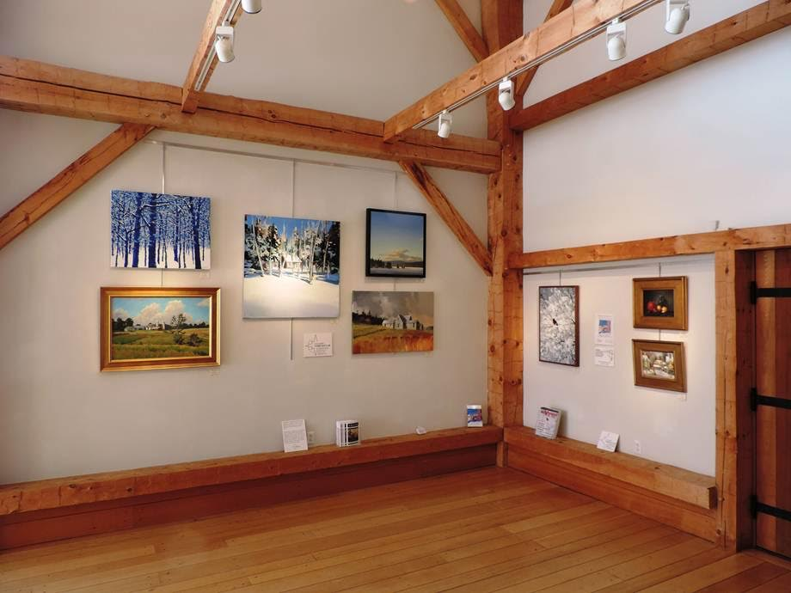 Left wall 6’ tall x 10’ wide. Right wall 5’ 2” tall x 7’ 6” wide.
SILO GALLERY

Southeastern Vermont Welcome Center
Interstate 91 North
Guilford Vermont

Exhibits are for Vermont artists. Art is on display for one month from 7am to 11pm daily.

Size of art must be 14” x 17”, or larger. Insurance is artist responsibility. Prices are not permitted on artwork.

Artwork needs to have wire backs. Each vertical hanging rod will hold 50 lbs. The horizontal wall strip will hold 150 lbs.

A sign with the name of your business, the town and your website need to be prominently visible.

Business/rack cards are displayed on bottom beams. Holders are provided.

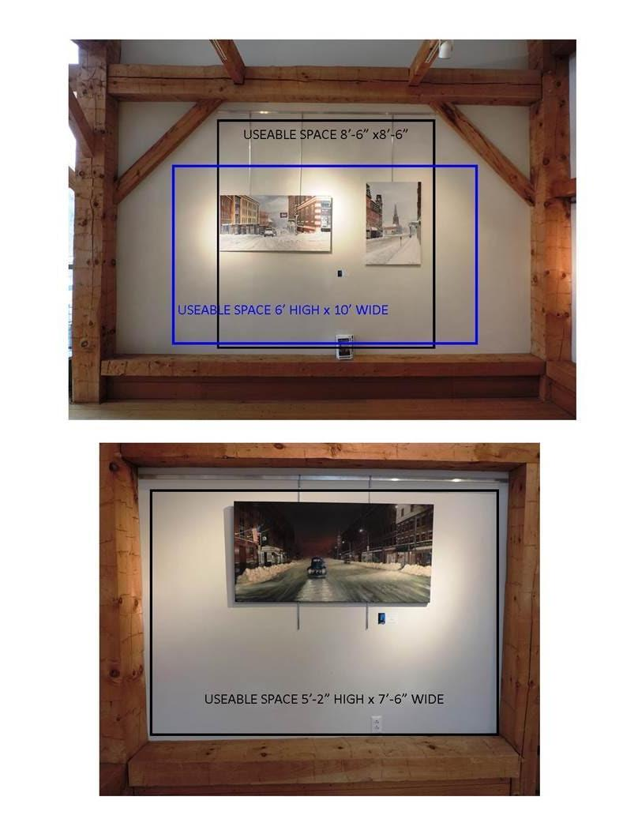

The center is listed as an official stop for the monthly Brattleboro Gallery Walk. A short artist write up/picture of your art work will be listed in the Gallery Walk publication.

Please email bgs.guilfordwelcomecenter@vermont.gov, for further information or to schedule an exhibit.

