Southeastern Vermont Welcome Center
Interstate 91 North Guilford Vermont

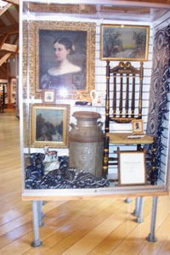
Display Case Information

Standard case measures 3 feet 10 inches wide, 4 feet 10 inches tall and 18 inches deep.
Large case measures 5 feet 10 inches wide, 4 feet 10 inches tall and 18 inches deep.
The slat board backing accepts hooks, shelves, and hangers. These along with assorted sizes of acrylic cubes are provided.
Prices are not permitted on any items on display.
A sign with the name of your business, the town and your website needs to be prominently visible.
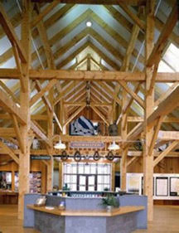
Business/rack cards will be placed on the shelf surround at the front desk. Holders for cards are provided.

Please email bgs.guilfordwelcomecenter@vermont.gov, for further information or to schedule an exhibit.

